

**OFFICER ROTATION**

[https://encrypted-tbn1.gstatic.com/images?q=tbn:ANd9GcQqXiEfoF7CWJQ0fHjZlnleSsPmQqpuSEMUUompcLqIttKXw3wC-V99LQhttps://encrypted-tbn1.gstatic.com/images?q=tbn:ANd9GcQqXiEfoF7CWJQ0fHjZlnleSsPmQqpuSEMUUompcLqIttKXw3wC-V99LQ](https://www.google.com/imgres?imgurl&imgrefurl=http://forums.meez.com/forums/suggestions/995670-wave-goodbye-animation.html&h=0&w=0&sz=1&tbnid=cTqLsyj93DkPTM&tbnh=53&tbnw=95&zoom=1&docid=v1eUQgjMyOLqOM&ei=96QoUviZHYmK9gTe6YDYAg&ved=0CAEQsCU)



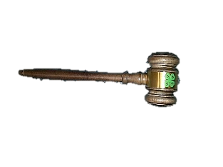President





American Pledge



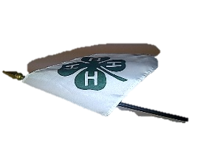

4-H Pledge





Vice-President

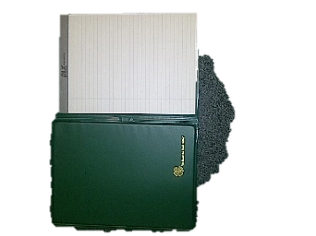



Secretary





Treasurer





Reporter

Member 1 Adjournment

Member 2 Adjournment

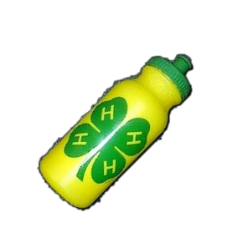

Recreation

Leader



Historian

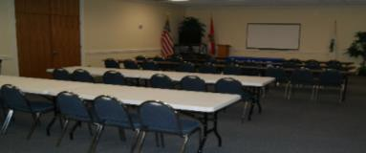Sargent-at-Arms

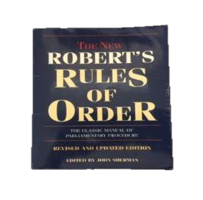

Parliamentarian

Extra Members