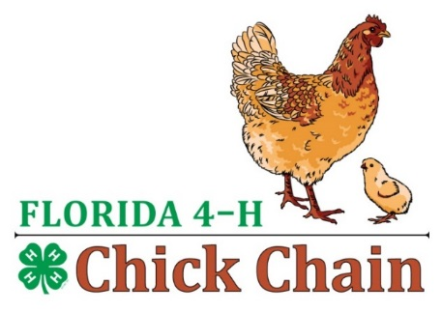
FL 4-H Chick Chain
Project Book Score Card

Name:
County:

Circle One: | Junior | Intermediate | Senior

Description: | Potential Score: | Judges Score:
Neatness | 20
Creativity | 20
Financial Info Included | 20
Feed Info Included | 20
Overall Completeness | 20
TOTAL | 100

Judges Initials:

Comments:

