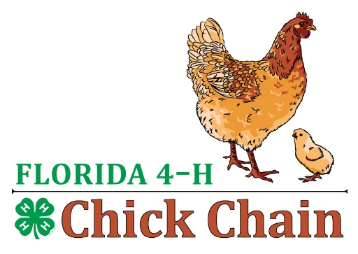
FL 4-H Chick Chain
Intermediate Showmanship Questions

- Name dual purpose breeds? ( Rhode Island Red, Plymouth Rock, Dominique, Wyandotte, Jerseys Giants, Delaware, Orpington)
- The long curved feathers of a male chicken’s tail are called? (Sickle)
- The American publication giving a description of all recognized poultry breeds is? ) The Standard Of Perfection Book)
- What is a brooder? (Brooder is a box or a pen that is a source of heat to keep chicks warmer during the first four weeks of age)
- A term used to describe a serious deformity or a defect which prevents a chicken from receiving an award? (Disqualification)
- Other than feathers, what other features are unique to the rooster? (Larger comb and wattles, coloring and spurs)
- What are the most common feed ingredients used in poultry diet in the U.S.A? (Corn and soybean meal)
- Do chickens have teeth? (Yes, an egg tooth at hatch to help break through the shell)
- What does “bleaching” mean relative to chickens? (Refers to the loss of skin color in laying hens, particularly in Leghorn type chickens, where the yellow pigment in the shanks fades to white as the pigmented used to color the yolk)
- Name a Bantam only breed? (Silver or Golden Seabright, Japanese bantams)
- What breed of chicken is used for the most commercial egg production? (White Leghorn)
- What is a pullet? ( a female chicken younger than one year old)
- What is a cockerel? (a male chicken younger than one year old)
- Why does the judge ask to see the feet and legs of the chicken? (to check for deformities and disease and for parasites)
- What does it means for a chicken to go “broody”? ( the hem want to sit on eggs or hatch eggs)
- What is a chicken doing when it is molting? (losing old feathers and getting new one)
- What is a female chicken called that is one year or older? (hen)
- What is a rooster? ( a male chicken one year and older)
- About how many eggs can a chicken lay a day? (one)
- What does “dual purpose” mean? ( good for meat and eggs)
- What is the importance of calcium in the diets of laying chickens? (for good egg shell
- What are external parasites found in chickens and where do you find them on your chicken? (Mites and Lice, check under the wing and on the skin under the feathers)
- Many starter feed for chickens are medicated. What disease is the medication able to prevent? (Coccidiosis – a disease of poultry caused by a protozoan-type parasite causing dehydration, blood loss and tissue damage. Symptoms include standing still (often on one leg) with their feathers ruffled up, wet feathers around their vent and watery white or yellow manure.
- If checking the legs of your chicken and find scales on the shanks are crusty and bumpy and swollen, what might your chickens have? (scaly leg mites)
- What gas can be produced by manure that is harmful to chickens? (ammonia)
- Do you find saddle feathers on a hen or a rooster or both? (a rooster)
- Where is the sickle feather on a rooster? (the tail)
- What are the feathers at the neck of a rooster called? (hackle feathers)
- What is the function of the vent? (where the egg-or poop comes out of)
- What precautions must be taken when you introduce new chickens to your flock? ( first check for disease, quarantine for 3 weeks and when introduce make sure there is no fighting among the chickens)

Questions the judge will ask you during showmanship
- What breed of chicken are you showing?
- What is you chickens purpose? (dual, meat or egg)
- What is there size? (heavy, very heavy, light, medium size)
- What type of comb do they have?
- Name some varieties of your breed of chicken? (refers to the different colors your breed can come in)
- Tell me a little about your chicken?

