Northwest Florida
Sponsored by the UF/IFAS
Panhandle Agriculture Extension Team

Virtual Beef Conference

Wednesday, February 10, 2021
Zoom Webinar Software

Sponsor the Virtual Beef Conference!

Due to COVID19, a traditional in-person cattle producer meeting with a trade show is not feasible this year. There is an opportunity to stay connected with your customers and potential customers in the Florida Panhandle, SW Alabama, and SE Georgia.

What is Virtual Beef Conference?
This year the Panhandle Ag Extension Team will offer a two-hour webinar with two invited speakers, brief updates from cattle and forage researchers, and a question and answer period at the end, instead of the typical half-day in-person educational program for cattle ranchers. In the past, we have offered a trade show during registration, lunch and during and extended break in the middle of the meeting. This year we are offering $50 sponsorships that put your product line, services, and contact information in the hands of every participant.

2021 Program Focus

2020 hit cattle producers really hard in the Tri-state region. COVID19 disrupted markets all across America, as beef supplies had to be shifted from food service customers to retail grocers, and meat plant production was disrupted backing up the supply chain. Tropical storms, and hurricanes, also flooded pastures and hay fields compounding issues locally. There is hope for the future, so the focus of the 2021 program will be Moving Forward from Disruption. Chris Prevatt, UF/IFAS Livestock & Forage Economist will provide a presentation on the Cattle Market Outlook for 2021 and Beyond to set the stage for the keynote speaker. Dr. Glenn Selk, Emeritus Beef Extension Specialist, Oklahoma State University, will provide the keynote video presentation entitled Cornerstone Concepts for Cow Herd Sustainability. His presentation will provide the foundation for profitable commercial cow-calf operations. Dr. Selk is known across the country for his weekly video and article series he calls, “Cow-Calf Corner.” Dr. Selk has 47 years of experience with Oklahoma State Extension, working primarily with cow-calf producers. The final presentation will provide a 20-minute overview of the most significant recent breakthroughs in cattle and agronomy research in Florida. The webinar will conclude with a Question & Answer Session to allow the speakers to address questions brought up during the presentations. This webinar will be held from 7:30 AM to approximately 9:30 Central Time (depends on questions submitted for discussion). As a follow up, recordings of each presentation will be uploaded to YouTube and shared through the Panhandle Ag e-News blog website for distribution via email, Facebook and Twitter for viewing after the live event.

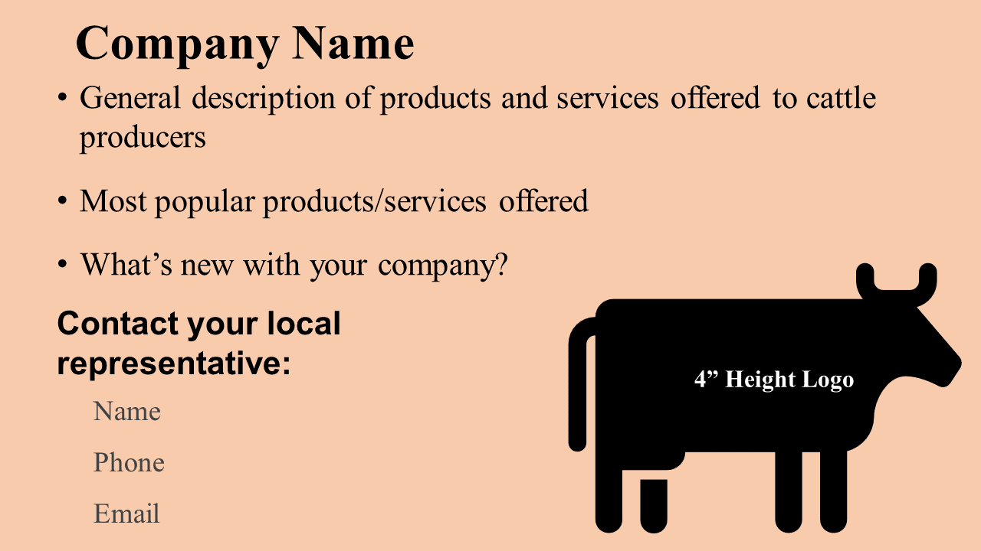
How does the sponsorship work?
We can’t have a trade show with no in-person audience, but we have created a unique opportunity to help you stay connected with current customers and provide a directory for potential customers. Each webinar participant will be required to preregister through Zoom, so that we can capture basic information which will include a current email address so that we can email them the proceedings. A resource page has been developed so the participants can also download the proceedings. This document will contain an agenda, participation instructions, speaker bios, and a listing of sponsor business cards (8 per page) similar to the graphic shown to the right. This same information will also be shared through a Panhandle Ag e-News article the week following the live webinar with the recordings of the presentations. This will provide two valuable opportunities to provide current information about the goods and service your company provides, as well as the best person to contact for more information.

Why is it worth $50 for my company?

Over the past few years175-200 cattle producers, extension faculty, and industry representatives from across the Tri-states region have attended the Beef Conference in person. We have never hosted a webinar of this type, so I can’t offer an audience estimate. However, we have learned over the past year that offering a live streaming event, as well as recorded videos post event have actually reached more producers, as people from outside the normal service area can participate, and can view the information on their schedule from the recorded presentations. We have developed a large following for our weekly e-Newsletters with 4,765 subscribers, and over 3,000 Facebook and Twitter account followers. The point is that we have developed a following of farmers and ranchers in the tri-state region over the past 9 years. This is an opportunity to share information about your company/organization at a time when it is difficult to make connections with customers.

What do you have to do?
- Online registration: Utilize the Eventbrite registration website:
https://2021-nwfl-beefconf.eventbrite.com. You will enter the required information and pay in one simple step. Due to publishing deadlines for the proceedings, the registration deadline is Monday, February 1, 2021.
- Create a PowerPoint slide for your company/organization in the widescreen format (16:9 7.5” high x 13.3” wide). After registering as a sponsor, a template will be emailed to you like the example used above. If you, or someone from your organization are not able to create a slide, the Jackson County Extension Staff can assist you with that, if you can email us a logo and the basic information.
- Email your company slide to me at the email address below.
- Tune in and take part in the live webinar. You will need to register as a participant, so that you will receive the information, but there is no charge to participate. Use the following link to register to participate in the webinar: https://tinyurl.com/NWFLBeefConf

Sincerely,
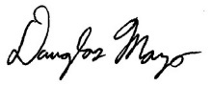
Doug Mayo, Beef Conference Coordinator
Jackson County Extension Director
850-482-9620 - demayo@ufl.edu

