Wildflower Seed Bombs

Materials
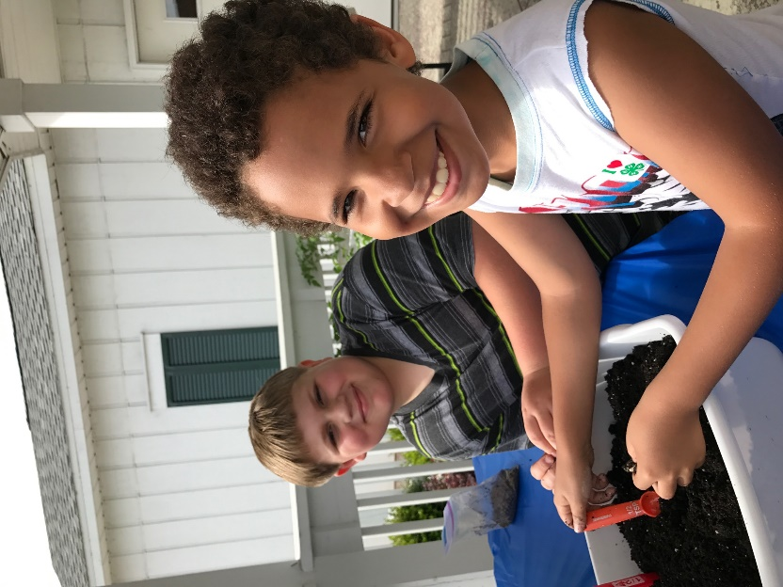
Air-dry clay
Wildflower seeds
Potting Soil

Instructions
- Pinch off a small amount of air-dry clay - enough to make a ball about the size of a bouncy ball. (about 1 inch diameter for our more precise readers)
- Work equal parts seeds and soil into the clay and form it into a ball. Amounts really are up to you. More seeds = more flowers. But too much soil will keep the ball from holding it’s shape. If this happens, add more clay and either have a bigger bomb, or divide it into two smaller bombs.
- Now for the fun part! Store them in a cool dry place until you’re ready to spread some wildflower cheer and then toss them where you want flowers to grow. (If you’re not using them right away, let them dry completely before storing in air-tight containers.)

Notes
- The air-dry clay acts as a binder only. It is a natural clay and as such is non-toxic. The added advantage is that when wet, it will soften and allow the seeds to grow.
- If you do not lay your seed bombs out to dry completely before you store them in an airtight container, there may be enough moisture in the clay and soil to sprout them, which means no flowers later, so take this step if you’re not launching them right away.
- Be careful when throwing your seed bombs. First, don’t hit people, animals, or other anything else with them. Just the ground. Second, some people throw them out along roadways or in abandoned lots. This won’t be useful if these places are mowed regularly, because if they get to bloom at all, they won’t last long. Also, you may need permission for this.

