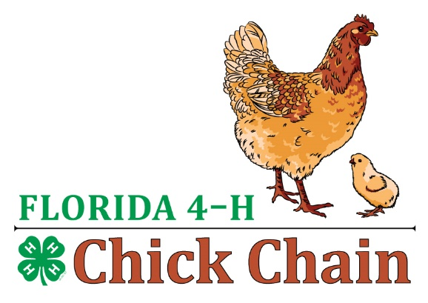
Fl 4-H Chick Chain
Cloverbud Showmanship
Questions

- What is your chickens name?
- What breed is your chicken?
- Is your chicken a girl (pullet) or a boy (rooster)?
- What color is your chicken?
- How do you take care of your chicken? (feed it, water, play with it etc.)

