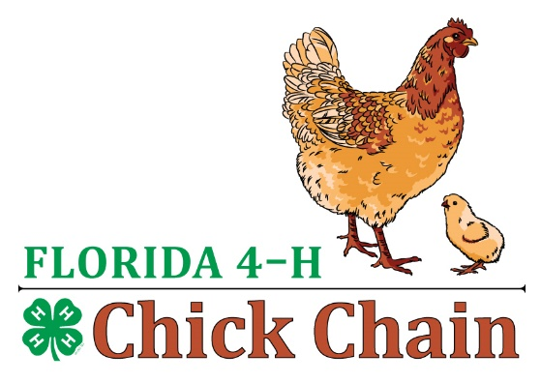
FL 4-H Chick Chain
Junior Showmanship Questions

- What is a Pullet? (Pullet is a young female chicken less than a year old)
- What is a Hen? ( A female chicken that is one year or older laying eggs)
- What is a Cockerel? ( A male chicken less than one year old)
- What is a Rooster? (A male chicken one year or older)
- What is the most common type of comb? (single comb)
- How long does it take for a chicken egg to hatch?? (3weeks or 21 days)
- About how many eggs a chicken can lay a day? ( One a day)
- What does molting mean? (Losing old feathers and getting new feather)
- At what temperature would work best for incubating eggs? (99 ,100 or 101)
- Where on the body of a chicken would you find the muff? (chin)
- Where on the body of a chicken would you find the crest? (on top of the head)
- What color of eggs do most chicken breeds lay? (brown)
- Does a chicken have an ear? (yes)
- Does a silkie have fur or feathers? (feathers)
- What does “dual purpose” mean? (good for meat and eggs)
- When a hen goes broody, what does she want to do? (sit on eggs or hatch some chicks)
- If a hen has red earlobes, what color eggs is she mostly likely to lay? (brown)
- Do you need a rooster for a hen to lay eggs? (No if you do not want to incubate the eggs for hatching)
- Name some predators you must protect your chickens from? ( foxes, skunks, dogs, raccoon, coyotes, hawks and owls )
- Name 3 things that affect how many eggs a chicken lays? ( age, breed, health, length of daylight, feed)
- What is the book called where you can read about how a perfect bird of a breed should look? (The Standard Of Perfection Book)
- If you have 2 black chickens, one with feathers on its legs and one clean legged, can they be the same breed? (no)
- If you have 2 chickens, one with red earlobes and one with brown earlobes, can they be the same breed? (no)
- What is the difference between a bantam and large fowl? (Size. Bantams are smaller)
- What are basic signs of good health in chickens? (alert, active, clear eyes, good manure consistency, and free from external parasites)

Questions the judge will ask you during showmanship

- What breed you chicken are you showing?
- What is their purpose? (dual, egg or meat)
- What is there size? (heavy, very heavy, light, medium size)
- What type of comb do they have?
- Name some varieties of your breed of chicken?/ (different colors the breed can come in)
- Tell me a little about your chicken?

