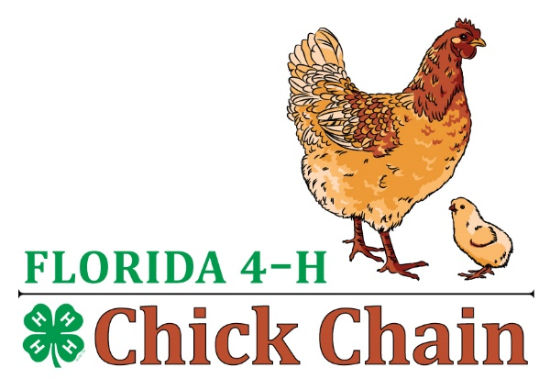
FL 4-H Chick Chain
Senior Showmanship Questions

- What does depth of body indicate? (size of abdomen and ability to hold a forming egg)
- What does width of body indicate? (size of body across the pelvic bone, room for egg)
- Why do we measure flexibility of public bone? (to see if they will open enough for an egg to pass)
- How many eyelids does a chicken have? Why? (3, upper, lower and nicating membrane which moves drown the front to the rear of the eye and is clear)
- How many feather tract do chickens have? (10 – head, neck, shoulder, wings, breast, back, abdomen, rump, thigh and legs)
- Where is the axial feather found and how many do chickens have? (on wings between primary and secondary flights, one on each wing)
- What is the difference between a broiler, a roaster, and a capon? (Broilers are young birds, usually processed at 6-8weeks of age. Roasters are usually 10-14 weeks of age and Capon a castrated meat bird grown to about 18-20 weeks of age)
- What is “Biosecurity” and why is it important for your flock of birds? (Biosecurity means preventing infectious or disease causing organisms and other pests, like insects, rodents, etc. from coming in contact with your birds. Keeping human traffic to a minimum, and not allowing contact with sick birds, either directly or indirectly through. Keep a pan filled with bleach near your coop and dip your shoes before and after entering your coop. Also wash your hands before and after entering your chicken coop)
- What is the relative humidity that helps eggs hold their maximum quality? (70-80%)
- Do chickens ever have teeth? (Yes. They have an egg tooth at hatch to help break through the shell. This tooth is different from teeth as it is not composed of enamel)
- What are some of the methods for verifying that a hen is currently laying egg? ( Width between pelvic bones equal the width of 3 human fingers, the vent is large, soft and moist rather than small and dry, comb is larger and redder)
- What are 2 other names for the breast bone of chickens? (Sternum and Keel)
- Other than feathers, what other features are unique to the male chickens? ( larger comb and wattles, coloring and spurs)
- Why is diarrhea a concern and how can it be treated in chickens? (It can lead to dehydration and possibly death, one needs to rehydrate the chicken by providing electrolytes and water and then determine the cause. A high load of worms, coccidiosis or bacterial infection of the gut can often lead to diarrhea.
- What is a hen? ( a female chicken one year or older)
- What is a pullet? (a female chicken younger than one year)
- What is a rooster? ( a male chickens one year and older)
- What is a cockerel? ( a male chicken younger than one year)
- What is the function of the vent? Is it common in poultry? (It is where the egg, uric acid and feces all exit the chicken from. Yes all chickens have one)
- What nutrients do chickens require each day? )protein, carbohydrate, fats, minerals, vitamins, water and oxygen)
- Why do some people feed their chickens Chicken Grit? ( Chicken do not have teeth – they storage grit in their gizzards to help grind up their food for digestion)
- Why should chickens be removed from and placed into cages head first? )to prevent possible wing and feather damage, to maintain control of them)
- What breeds of chickens lay blue-green eggs? ( Araucana and Ameraucana)
- Why should incubators be disinfected prior to use? ( to remove any bacteria, virus, mold organisms that might infect the eggs being hatched)
- What need to be supplied in an artificial incubator to hatch eggs? (heat, humidity, and turning)
- What are nest boxes and what are they used for? ( nest boxes are boxes place in with the hen for her to lay and hatch her eggs in)
- A term used to describe feathers which are curled or which curve outward and forward. It is desirable characteristic of certain breeds?? (Frizzle feathers)
- Two alternating colors on a feather running across the width of the feathers is called? (Barring)
- What color eggs do Rhode Island Red, Barred Rock, and Buff Orpington chickens lay? (brown)
- What does “dual purpose” mean? (good for meat and eggs)

Questions the judge will ask you during showmanship
- What breed of chickens are you showing?
- What is their purpose? (dual, meat or egg)
- What is there size? (heavy, very heavy, light, medium size)
- What type of comb do they have?
- Name some varieties of your breed? (different colors the breed can come in)
- Tell me a little about your chicken?

